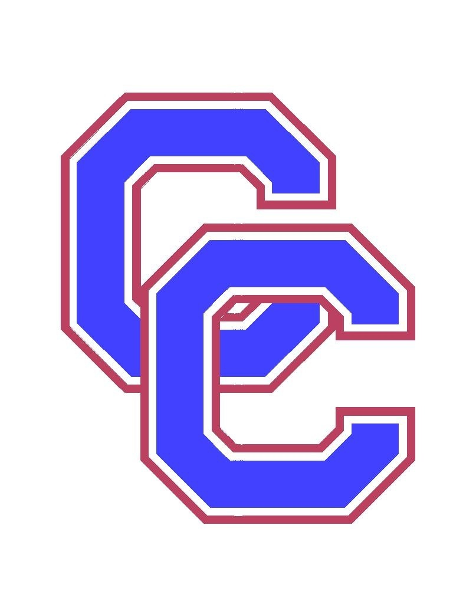

October 6, 2026

Dear Speech and Debate Coach,

You are cordially invited to the 16th Annual Cherry Creek Classic held in-person at Cherry Creek High School on November 7, 2026.

Events: We will be offering three rounds and finals in Drama, Humor, Poetry, Duo Interp, POI Program Oral Interpretation, National Extemporaneous Speaking, International Extemporaneous Speaking, Original Oratory, Informative Speaking, Impromptu Speaking, Improvisational Storytelling, Varsity CX Debate, JV CX Debate, LD Debate, and Public Forum Debate. We will also offer Congressional Debate.

Rules:
- Each school (administration, teachers, and/or coaches) is responsible for ensuring they have proper parental permission for students to participate in an online tournament and to use the designated competition platforms.
- A responsible coach must be available ON-SITE and VIA CELL at all times.
- Competition is open to 9-12 grade students representing the school in which they are officially enrolled and doing so with the permission of their school administration and/or coaches.
- We will use CHSAA rules in all events, except Congressional Debate. We will use NSDA rules in Congressional Debate.
- We will use the NSDA cross-examination format in the final rounds of National and International Extemporaneous Speaking.
- All competitors and judges must have a speechwire account to log in.
  - Ben at Speechwire has provided video resources to explain the creation of student accounts, judging online, viewing ballots and competing online. Please check them out. https://www.speechwire.com/p-video-resources.php

Doubling Rules:
- CX, JVCX, PF, and LD Debaters may not double-enter.
- Congressional Debate students may not double-enter.
- Students in events may double-enter in two events. Students are responsible for making it to their rounds. Students must pay attention to the schedule because we may not be using a full wave system- some events will occur in the same time period.
- Students can only enter one Extemp event.
- Extempers that double-enter risk losing part of their prep time.

JV/Varsity CX Rules:
- Varsity CX Debate is open to all debate teams.
- JV CX Debate is limited to freshman and sophomore debaters and to students in their first year of competition.
- In JV CX Debate, no kritiks or counterplans are allowed.
- In JV CX Debate, we will employ the NFHS Novice case limits, meaning that all teams should limit themselves to these case areas:
  - Medicare for All — this affirmative is a single-payer, government-run system eliminating private insurance to cover everyone. It would be based on the current Medicare model.
  - Revise/Expand the Affordable Care Act — this affirmative would strengthen the 2010 Affordable Care Act, likely by strengthening the individual mandate and restoring federal subsidies for marketplace health insurance plans.
  - Single Payer Option to Replace Private Health Insurance — this affirmative is also a single-payer, government-run system eliminating private insurance to cover everyone, but it would not necessarily be based on the existing Medicare model.

Debate Resolutions: We will use the 2026-27 NSDA CX topic (Health Care), the November-December NSDA LD topic (De-Extinction), and the November-December NSDA PF topic (Europe NATO TPNW).

Entries: A maximum of four (4) entries will be allowed in each event, except Congress, which will be limited to ten (10) entries per school. Additional entries may be placed on the waitlist and we will accommodate those entries if space is available.

Registration: All registration will occur at www.speechwire.com. Registration will close on Friday, October 24. Registrations are handled on a first-come, first-served basis.

Fees and Payment: The entry fee will be $12.00 per student in events and $10.00 per student in Congress, based upon the pre-registration numbers on Wednesday, October 28. Changes in pre-registration will be reflected in the final entry fees if made via the web site by October 28. After that time, net increases in entries will result in increases in final entry fees, while net decreases in entries will not reduce your final entry fees.
- Please make checks payable to CCHS Speech and Debate Team. Please mail payment to Marti Benham, Cherry Creek High School, 9300 E. Union Avenue, Greenwood Village, CO 80111.
- If you would like to pay by credit card, please go to https://cherrycreek.revtrak.net/cch/cch-speech-and-debate-external

Mission, Vision, Inclusion, Harassment, and Discrimination:
At Cherry Creek Speech and Debate Tournaments, we embrace and support the mission of our school district, the vision of our school, the CHSAA Speech and Debate Inclusion Statement, and the NSDA Harassment and Discrimination Policy. Please review the attached document.

Registration and Schedule: Check-in will be held from 7:00- 7:15am. All schools must check-in by 7:15am. Rounds will begin promptly at 8:00am. Awards are scheduled for 7:30pm.

Awards: We will be awarding trophies or medals to all finalists. Additionally, numerous superior and excellent ribbons will be awarded. Team awards will be given to the top three schools. The host school is not eligible for team awards.

Congressional Debate: The docket will be posted at www.speechwire.com.

Judging: Each school is responsible for providing judges to cover their entries. Judges must be available for the three preliminary rounds and the final round. One judge must be provided for every two debaters. One judge must be provided for every 5 events entries. Judges must be entered in Speechwire by Tuesday, November 3. Judges are responsible for checking for ballots at the appropriate times. Judge fees will be imposed for missing judges and for judges who miss ballots.

Site: The tournament is being held at Cherry Creek HS, 9300 E. Union Avenue, Greenwood Village, CO 80111.

Questions and Concerns: Please feel free to contact Marti Benham at Cherry Creek High School, 720-554-2216 (school), 303-921-9411 (cell), mbenham@cherrycreekschools.org

We look forward to seeing you and hope you will be able to join us!

Mission, Vision, Inclusion, Harassment, and Discrimination

At Cherry Creek Speech and Debate Tournaments, we embrace and support the mission of our school district, the vision of our school, the CHSAA Speech and Debate Inclusion Statement, and the NSDA Harassment and Discrimination Policy.

Cherry Creek School District Mission
At Cherry Creek Schools, our mission is to inspire every student to think, to learn, to achieve, to care.

Cherry Creek High School Vision
Each member of the CCHS community will be equipped intellectually, socially, and emotionally in pursuit of their chosen path.

CHSAA Speech and Debate Inclusion Statement
The CHSAA Speech and Debate community believes inclusion is vital to our community. We are committed to providing a safe and equitable learning and competitive environment that fosters a mindset of empathy, respect, and belonging for all involved in Speech and Debate, including, but not limited to students, coaches, judges and community members. We honor differences including races and cultures, genders and sexual orientations, abilities and aspirations, identities and affiliations, socioeconomics and worldviews. Embracing our diversity prepares our community to thrive. Individuals found to have violated this policy will be subject to the full range of sanctions, up to and including removal from the tournament premises.

National Speech & Debate Association Harassment and Discrimination Policy
The National Speech & Debate Association is committed to providing its participants, judges, coaches, and staff the opportunity to pursue excellence in their endeavors. This opportunity can exist only when each member of our community is assured an atmosphere of mutual respect. The NSDA prohibits all forms of harassment and discrimination. Accordingly, all forms of harassment and discrimination, whether written or oral, based on race, color, religion, sex, gender identity or expression, sexual orientation, marital status, citizenship, national origin, age, disability, genetic information, or any other characteristic protected by any applicable federal, state, or local law are prohibited, whether committed by participants, judges, coaches, or observers. Individuals who are found to have violated this policy will be subject to the full range of sanctions, up to and including removal from the tournament premises.

2026 Cherry Creek Classic Topic Areas

Congressional Debate
The Congressional Debate Dockets will be posted at www.speechwire.com on the Files for Download tab. The Docket order is set for each session.
- Congress will have three rounds or sessions and a Final round.
- There will be a new PO for each session.
- Precedence will start over for each session.
- We will use direct questioning during the session.

Extemporaneous Speaking Topic Areas
We will use the NSDA cross-examination format with a 2-minute questioning period in the final rounds of National and International Extemporaneous Speaking. We will draw in 8-minute intervals during prelims and 12-minute intervals during finals.

National
Round 1 - Trump Administration
Round 2 - Artificial Intelligence
Round 3 - Constitutional Issues
Finals - Midterm Elections
International
Round 1 - Africa
Round 2 - International Economics
Round 3 - Middle East
Finals - International Organizations

Impromptu Topic Areas
Students will draw 3 topics and choose one. They will have 5 minutes to prepare a 3-5 minute speech. Complete rules and instructions can be found on the ballot posted on Speechwire and used during the tournament.

Round 1 - Dolly Parton Song Lyrics
Round 2 - Famous November Birthdays (e.g., Marie Antoinette - November 2nd, 1755)
Round 3 - Winston Churchill Quotes
Finals - It Happened 50 years Ago (1976)

Improvisational Pairs Topic Areas
Students will draw 3 topics and choose one. They will have 10 minutes to prepare a performance that is a maximum of 7 minutes with a 30-second grace period. Complete rules and instructions can be found on the ballot posted on Speechwire and used during the tournament.
Round 1 - New Speech & Debate Coach (e.g., Supervillain Takes Over Team)
Round 2 - Robots Gone Wrong (e.g., Robot Babysitter)
Round 3 - Fantasy School Field Trips (e.g., Field Trip to Middle Earth)
Finals - Driving Instructor (e.g., Teaching Frankenstein to drive)

Lincoln-Douglas Debate – 2026 November-December Topic
Resolved: De-extinction is unethical.

Public Forum Debate – 2026 November-December Topic Area
Resolved: European members of the North Atlantic Treaty Organization should ratify the Treaty on the Prohibition of Nuclear Weapons.

Policy Debate – 2026-2027 Topic
Resolved: The United States federal government should establish national health insurance in the United States.
- Varsity CX Debate is open to all CX debate teams.
- JV CX debate is limited to freshman and sophomore CX debaters and students in their first year of competition.
- In JV CX, no Kritiks or counterplans are allowed.
- In JV CX, we will employ the NFHS Novice case limits, meaning that all teams should limit themselves to these case areas.
  - Medicare for All — this affirmative is a single-payer, government-run system eliminating private insurance to cover everyone. It would be based on the current Medicare model.
  - Revise/Expand the Affordable Care Act — this affirmative would strengthen the 2010 Affordable Care Act, likely by strengthening the individual mandate and restoring federal subsidies for marketplace health insurance plans.
  - Single Payer Option to Replace Private Health Insurance — this affirmative is also a single-payer, government-run system eliminating private insurance to cover everyone, but it would not necessarily be based on the existing Medicare model.

